Pastoral Council Report

The 2nd Year of our 3 Year Term 2015-2016
The Parish Pastoral Council has a large role in the function and management of our Parish. Members of the Council are committed to strong leadership on your behalf.

Parish Surveys
The mandated Parish Planning Survey consumed much of our time at the beginning of this second year. We gathered information from 69 families to help access the viability of our parish. The results of the survey were shared with both our parishioners and the archdiocese. This provided the Council with valuable information as we move forward and has become the foundation of our goals and the directions we are passing along to our commissions. The parish community then had the opportunity to give input on what parish leadership model would be preferred in light of the priest shortage. By vote, the top two choices were the “Twinning” model we had for much of the year and the Parish Life Coordinator model, which is what we have now under the leadership of Deacon Ken Clemens.

Transition
This has been quite a year of transition for all of us. When Fr. Jim Grey transferred to his new location, we all adjusted to the leadership of Fr. John Paul Hopping. This presented some growing pains as everyone tried to get the details right while we shared leadership with another Parish. The difficulties Fr. John Paul experienced trying to manage two parishes became apparent and the Council worked on behalf of the Parish to get some help from the Archdiocese. Our calls for help were answered, and Deacon Ken was named as our Parish Life Coordinator. This is a blessing for both our Parish and for Fr. John Paul.

Goals of the Parish
We have put forth a series of Goals for everyone to focus their attention. We feel like this will help all of our groups, organizations, and leaders to be on the same path forward. These Goals are as follows:
Parish Goals:
Evangelization: focus on prayer in building the life of our faith community; attract new people into the church through: reestablishing a welcome structure, RCIA, PSR, good liturgy, teen/young adult programs, ongoing adult faith formation, prayers for peace, and increased community involvement and visibility in Maplewood and surrounding areas.
Stewardship: build an environment of giving through: the offertory, participation in commissions, service to the poor, and volunteering with parish events and programs.
Facilities: target most needed maintenance and repair items; improve rental income; develop a plan to raise money for the future renovations that are identified as a priority.

Resource Guide
We asked Parishioners to share their strengths and talents. After gathering the information, we compiled a Resource Guide for everyone. When we have a need, we can tap into our internal resources first. This may save time and money for the Parish. The master copy of this is being stored in the office computer so it can be updated easily. If you would like a copy, or want to add yourself to the guide, please contact Eva in the office and she can email or print a copy for you.

Structure for Parish
After evaluating the Commissions and the roles of our Staff, it became apparent that we needed to clarify the way our system functions. So we composed and circulated parish-wide a Flow of Information Chart for easy reference:

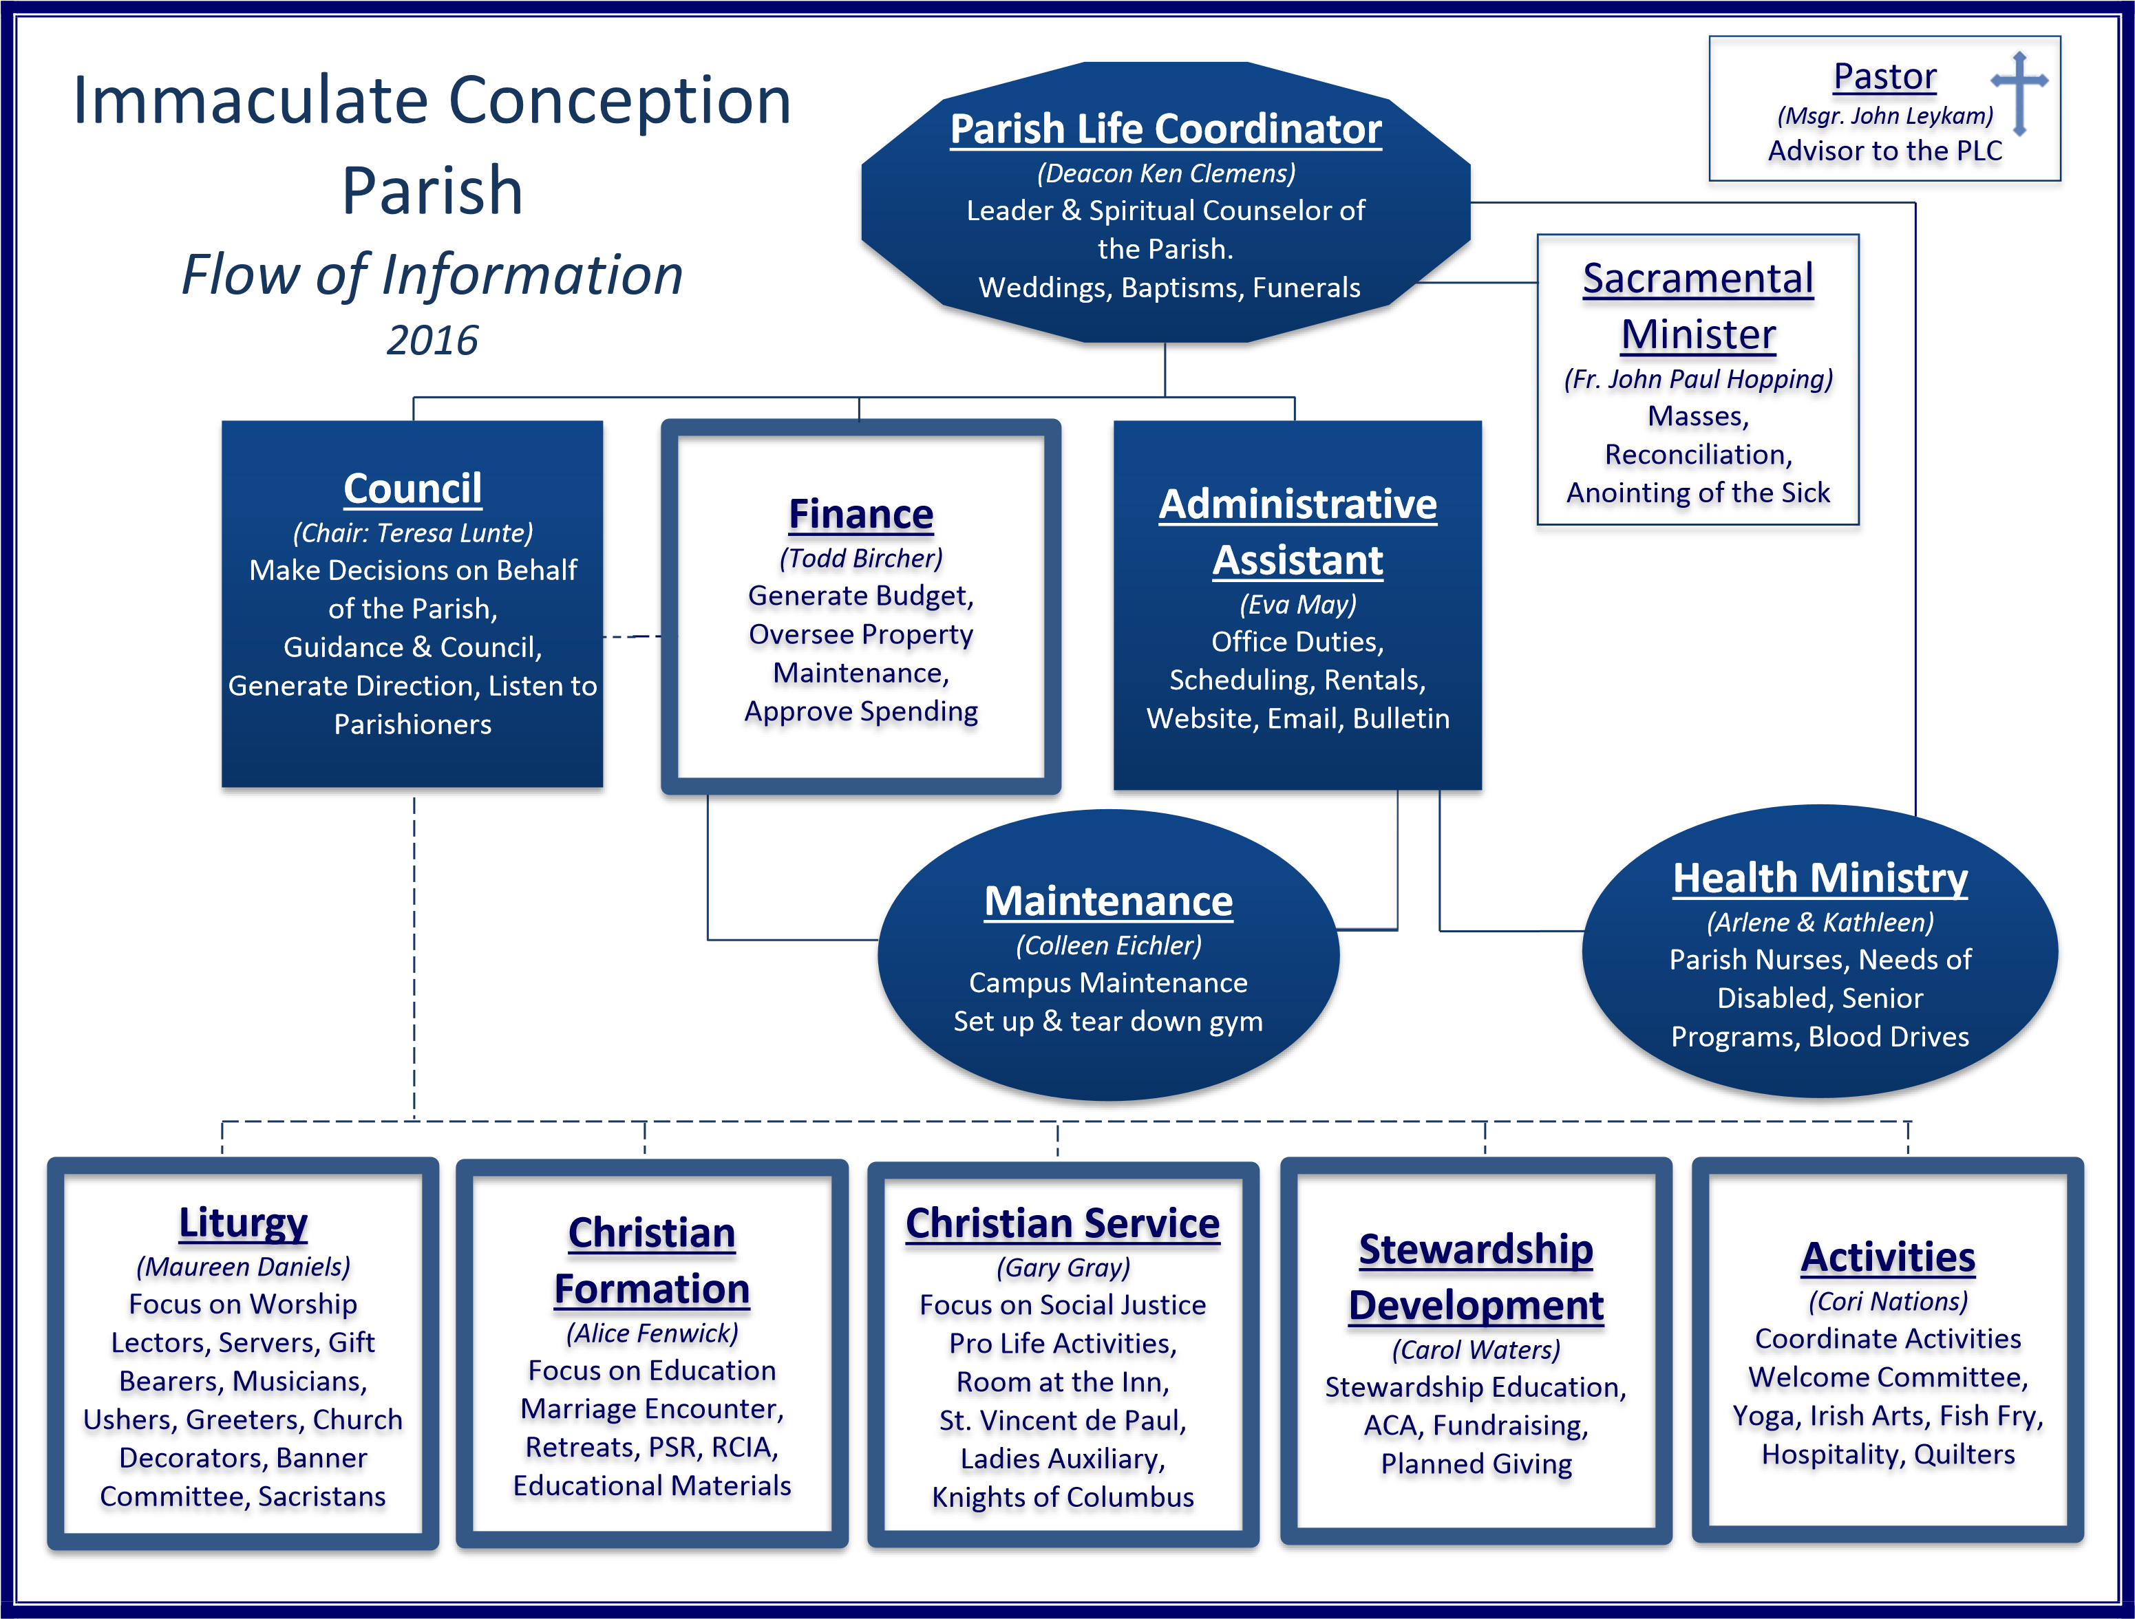
Commissions
After reviewing the Commissions, we consolidated the roles. Parishioners have stepped up and we have leadership in each commission. This year we are asking each commission to choose a month to promote itself. This is a time to focus on what each commission does, what it needs, and how you can participate. The Parish Council offered these guidelines to the Commissions.
NOTES FOR COMMISSION LEADERSHIP
1. This is a 3-year term. Keep this in mind by planning and training a replacement as your term approaches its end.
2. Choose a month in the calendar year for your Commission to use as a means of promoting your work and encouraging participation from the rest of the Parish. This month would be a time to issue a yearly report to the entire Parish reporting on activities, policies, or budgets depending on which Commission you lead.
NOTES FOR COMMISSION LEADERSHIP (continued)
3. Bring representation from the different ministries into your meeting or discussions. You will be assuring that the goals and direction of the Parish are passed along to these Ministries.
4. Forward minutes from your meetings or major decisions to the Parish Council prior to our monthly meeting. This is not for permission; it is just a means of keeping all communication open. This will allow the Council a way of measuring the success of the Parish Goals.
5. Review the Goals the Parish Council sends forward and work to align these with the work within your Commission.
6. When communicating with the Parish, consider yourself a "Marketing Team".
We are more than just sign-up sheets and money gatherers. Tell us how your event promotes community, strengthens worship, raises funds for a specific goal, or educates us about our faith. Give the "what", "why", and the goal. Let everyone know what he or she will gain as well as what you need.
7. As you plan events / services / fundraisers be mindful of the diversity of ages, abilities and needs of the Parishioners. Are you focused only on adults? Have you considered the young busy family? How about our youth- did you plan on how they will participate?

Mass Schedule
The Parish Council held a joint meeting with the St. Luke’s Council/ Leadership team to work out the Mass Schedule between the two Parishes since Fr. Tony is moving to his next assignment, and Fr. John Paul will assume responsibility for all the Masses at both Parishes. The Immaculate Conception schedule changed little to preserve some stability for our Parishioners and our PSR families and Staff. The New Mass Schedule is as Saturday @ 4:00, and Sunday @ 9:00.
We hope you noted the Leadership your Parish Council has provided this year. We worked hard to maintain as much stability for our Parishioners as possible during this year of many changes. We have advocated hard for the needs of IC, among the flood of challenges the Archdiocese is facing. We are proud of our work, and we are proud of all of you too! Thank you for your patience, tolerance, dedication, loyalty, and good spirits—qualities that continue to make us strong in community.
Prayerfully,
Teresa Lunte, Ellen Simmons, Marie Mudd, Thomas Hannan, Robert Bott, and Deborah Lee

